Microsoft is taking the next step in modernizing their customers’ Microsoft licensing procurement journey with their announcement of adding seat-based products to the New Commerce Experience (NCE).

Previously called Modern Commerce, New Commerce Experience (NCE) is now the most modernized buying vehicle for Microsoft licensing customers. The current Cloud Solution Provider (CSP) model that has been available since CSP inception is now called ‘Legacy’ or ‘Legacy CSP’.

NCE SKU’s will be generally available starting January, 2022*. Starting March 1st, 2022, NCE will be the only way to transact new seat-based products.

*\*10/08/2021 Update: Microsoft has decided to push the generally available date from the originally announced October 2021 date to January 2022.*

As many customers are aware, today’s Microsoft licensing experience includes a dizzying array of programmatic choices. Customers have Volume License Agreement options such as Enterprise Agreement (EA), MPSA (formerly known as Select), Open Business, and Open Value. Alternatively, customers can purchase through Microsoft Direct at retail pricing with no partner support, or through a Cloud Solution Provider (CSP) partner to receive value-added support and pricing breaks. Each one of these purchasing vehicles comes loaded with its own set of terms, conditions, licensing rules, stipulations, caveats, and complexities.

In 2019, Azure Plan became the first subscription category to move from Legacy CSP into the New Commerce Experience (NCE). Then, in 2020 and 2021, Microsoft began including perpetual software into NCE. The latest announcement from Microsoft rounds out the NCE portfolio by adding in the per-user/seat-based subscription licenses into the buying program, such as:

* **Microsoft 365**
* **Dynamics 365**
* **Windows 365**
* **Power Platform**

**The New Commerce Experience:**

Microsoft’s main objective is to simplify the buying experience for their customers. Moving forward, under the New Commerce Experience (NCE), all buying options will be governed by one contract: the Microsoft Customer Agreement or MCA. Microsoft is moving away from the disparate program-specific offers to three new buying motions. The size, scale, and support requirements of your organization will determine which option is the best fit for you as the customer.

**Question: was the retirement of open licensing (OLP) connected to NCE?**

* Yes, most definitely connected. As of the 1st January 2022 customers will no longer be able to create or add to an existing Open licensing agreement. Instead this has now been opened up within CSP for purchasing and managing perpetual licensing. BIST suspect that other Volume licensing programs will over time be retired with CSP (most likely) becoming their new home.

**NCE Buying Options:**

* **Breadth Motion** – Cloud Solution Provider (CSP) through a Partner ideal for customers between 0-2400 seats
* **Enterprise Motion** – Enterprise Agreement for 2400 seats or complex global licensing requirements
* **Self-Service Motion** – Web Direct with Microsoft this includes both corporate and domestic customers

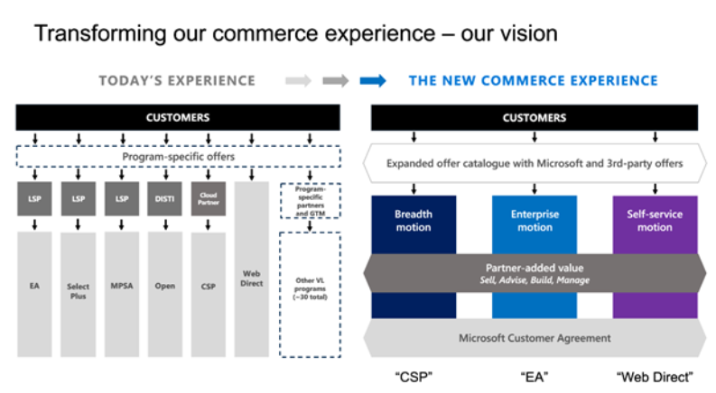

The NCE announcement has opened the Breadth (CSP) motion to a much larger customer audience based on comparative pricing and value included in each buying option. Due to this, the Breadth (CSP) motion is now the primary and foundational buying motion under New Commerce Experience. Any organization looking for the most value out of their Microsoft licensing contracts should start by fully evaluating the Breadth (CSP) buying motion.  Organizations above 2400 seats might also consider the Microsoft-led Enterprise Motion (EA), and organizations below 50 seats might also consider the Microsoft-led Self-Service Motion (Microsoft Direct).

**Understanding the NCE New Term Offers:**

Many Legacy Cloud Solution Provider (CSP) customers thoroughly enjoyed the flexibility the program offered in the past. Customers were able to cancel subscriptions at any time, add and reduce licensing as required, and pay per day of use. Under NCE, customers still have the option to have *similar* flexibility, but it will come at a premium price compared to the alternative annual/multi-year options. There will now be two license term choices for customers with differing caveats to each:

**NCE Short-Term Commitment (Premium price):**

* Term: Monthly for term flexibility
* Available at a premium in recognition of the flexibility included (20% price premium when compared to annual/multi-year pricing option)
* No price protection, month-to-month exchange rate
* 72-hour cancellation window for new purchases
* Quantity increases possible; no decreases during term (instead schedule decrease for end of term/end of month)
* Upgrades are permitted mid-term for some products; downgrades are not permitted on any license during term (instead schedule replacement for end of term/end of month)

**NCE Long-Term Commitment:**

* Term: Annual or Multi-year for price predictability
* Available at a discounted price in recognition of your commitment to Microsoft (20% discount compared to monthly pricing)
* Expected to have pricing parity with Legacy CSP pricing (*Important Note: Statement does not include recent*[*Microsoft SKU-based price increases*](https://www.microsoft.com/en-us/microsoft-365/blog/2021/08/19/new-pricing-for-microsoft-365/)*which impacts both NCE and Legacy pricing)*
* Price protection for committed term (annual or multi-year)
* 72-hour cancellation window or at term renewal (annually)
* Upgrades are permitted mid-term for some products; downgrades are not permitted on any license during term (instead schedule for end of term)
* Quantity increases possible; no decreases during term (instead schedule decrease for end of term)

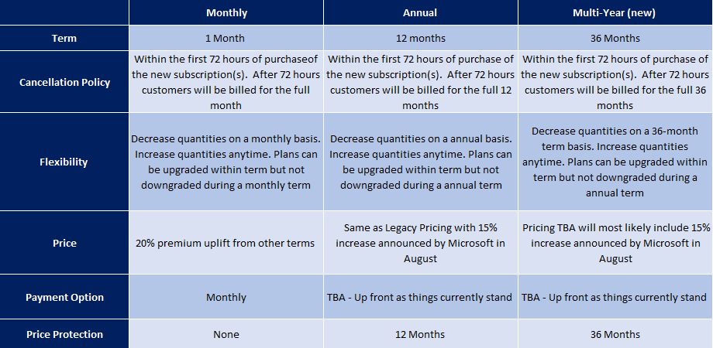

**Dissecting NCE – Pros and Cons for Customers:**

Microsoft’s aim to simplify the buying experience brings together many of the programmatic features of Web Direct, Enterprise Agreement, and CSP into one buying motion. As with any major Microsoft licensing change, it will take some time to learn the ins and outs of the new program. Generally speaking, we think most of the changes associated with the New Commerce Experience are beneficial for our customers, with a few major exceptions.

**The NCE Pros:**

* Price protection for up to 36 months now offered
* Billing is now aligned to calendar month
* Simple/scheduled conversion of trial licenses to paid offers
* All new offers will be aligned to NCE
* 1 Microsoft contract governing terms and conditions – Microsoft Customer Agreement contract
* Hybrid Use Benefit now included (no longer just a Software Assurance/EA benefit)
* New communication credit offers (no longer just an EA benefit)
* Multi-Geo capabilities included (no longer just an EA benefit)
* Scheduling of subscription changes/upgrades to new SKU’s (which removes the need for admins to make changes on anniversary dates)
* Auto-renew toggle (similar to Microsoft Direct)

**The NCE Cons:**

* Monthly terms now come with a 20% premium as a trade-off for flexibility,
* Cancellation policy is now enforced for 12 month and 36 month commitments, meaning you can only reduce licensing at the end of your term (but can still add licensing at any time)
* Customers can no longer switch licensing partners mid-term
* Microsoft will hold customers to their term period - This means that partners/distributors will liable if customers are unable to pay. This is will mean partners asking for upfront payments from customers.

**BIST Key Recommendations on NCE:**

* We recommend customers work with a partner to identify and use a blend of long-term and short-term commitments of NCE to suit their specific licensing needs for employees.
* Annual and multi-year term commitments come with a pricing discount, but do not allow customers to reduce their committed seat counts during the term. To avoid paying for unused seat counts, we recommend working with a partner to determine your expected stable # base of employees and only committing that # of seats to an annual or multi-year commitment.
* Short-term commitments (monthly) come with a pricing premium but allow flexibility in reducing counts as needed. To avoid paying for unused seat counts, we recommend working with a partner to determine your expected variable # of employees (such as seasonal or contract workers) and committing that # of seats to a short-term commitment.
* Customers committing to an annual/multi-year NCE offer before end of February 2022 will avoid/defer Microsoft’s announced [SKU-based price increases](https://www.microsoft.com/en-us/microsoft-365/blog/2021/08/19/new-pricing-for-microsoft-365/), and may even receive a promotional discount from Microsoft for doing so.
* Find a trusted partner and work with them prior to the March 1st, 2022, NCE deadline to analyze your SKU-set, provide cost modeling, and make recommendations specific to your organization.
* Make sure you are with a high-quality licensing partner prior to committing to an NCE term as you can no longer switch partners mid-term. You must wait until the subscription term has ended with the current partner.

**Important NCE Dates to Keep in Mind:**

Below are some upcoming dates to keep in mind the important thing to remember is that it is an evolving situation and subject to change and adjustment but the key date is 1st March 2022

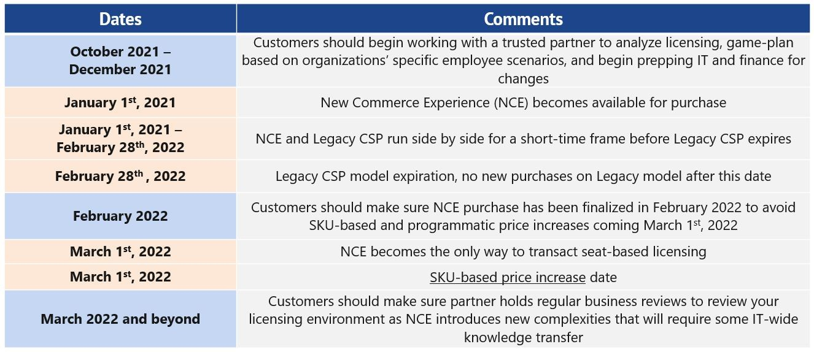

### Summary:

The NCE is a radical move to improve and simplify how customers licenses there environments and whilst many of our customers are used to a constantly changing Microsoft licensing landscape, the impact of New Commerce Experience will require an even more extensive effort for both the customer and partner to navigate together. It is important to have a trusted Microsoft partner in your corner helping your organization navigate these changes. Additionally, since you cannot change partners during an NCE subscription term, it is equally as important to find a partner you trust to manage your Microsoft licensing subscriptions throughout the full licensing term.